**5/2/2020**

Proposal for   
GAIT – Gaming product review website

**Course: CSE482.2**

**Submitted by:**

|  |  |
| --- | --- |
| **Name** | **ID** |
| Ishrat Jahan Ananya | 1631636042 |
| Md. Farhanuzzaman Reza Famous | 1510303042 |
| Sazid Alam | 1511394042 |
| Abul Morshed Arif | 1521478042 |

# Table of Contents

Table of Contents 2

Introduction 4

Background and product context 4

User Case Model 7

Use Case 1: 7

Use Case 2: 7

Use Case 3: 7

Solution Description 8

Architecture 8

Front-end plan 9

Back end development 9

UI mockups…………………………………………………………………………………………………………………… 9

Performance plan: 10

Open-source web page tester (https://www.webpagetest.org/) 10

Google Page evaluation (https://developers.google.com/speed/pagespeed/insights/) 10

Development Plan 11

Phase 1 11

Deliverables: 11

Phase 2 11

Deliverables: 11

Phase N 11

Hardware/Hosting Plan 12

Collaboration Plan 13

Project Schedule 14

# Introduction

This document presents a detailed description of GAIT – a gaming product review website. It will explain the goals of the project, the features implemented, the navigation of the user interface and finally the limitations and future-proofing aspects of this project. Furthermore, it mentions the development plan for the project phase by phase of over a time frame of three months.

# Background and Product Context

There is a gigantic number of people that spend a large sum of money on games and gaming products. Hence there is a huge market for items like gaming cards, game pads, mouse, keyboards etc. With so many options to choose from, it gets difficult to narrow down our choices that fit best with our requirements. More often than not, it is a tedious, research extensive process.

The solution to the problem is GAIT. The objective of this project is to create a web application that helps the user to choose the right product according to their preference. This cuts down on the time-consuming work put into searching the whole internet and asking around for reviews that would ultimately affect your purchase decision. GPR will host a vast collection of gaming products with their details and authentic reviews by users. It will also include ratings for every item. This allows other users to fill in their requirements, including the budget and discover the best option for them based on user reviews.

Moreover, there will be option for premium memberships. User can pay a subscription fee to get special features such as advertising their own product etc.

# Use Case Model

## Use Case 1: Registration

**Actor** – User

**Purpose** – user can create a new account on the website by providing an email address and password or use their google account.

**Condition** – none

## Use Case 2: Login

**Actor** – User

**Purpose** – user can request to login to their account. Once the system validates the user’s email and password they can be logged into the website.

**Condition** – user must be logged in

## Use Case 3: Search for product

**Actor** – User

**Purpose** – user can search for any gaming item in search bar of their homepage. The option to choose from similar items appear from which user can select any to view details of the product and compare reviews.

**Condition** – user must be logged in

## Use Case 4: Write Review

**Actor** – User

**Purpose** – User can post a picture of any gaming product or accessories, fill in the details of the product and write a review on it for others to see.

**Condition** – user must be logged in

## Use Case 5: Add/Delete reviews

**Actor** – Admin

**Purpose** – Admin has the option to view user activity and add or delete any reviews or products that violates product policy.

**Condition** – admin must be logged in

# Solution Description

## Architecture

The frontend will be a series of webpages developed with HTML, CSS, JavaScript and Bootstrap. The back end will consist of a database to contain all the information such as product details, user account details etc. The database will be handled using mysql and php. Payment method will be incorporated using API for premium membership of the users who would receive extra benefits.

## Front-end plan

A total of 4 page-templates in plan

1. Signup and Login page
2. User’s Homepage
3. Product Details and review page
4. Admin page

## Back end development

1. Account Creating, Password Recover:
   1. Sign up form, verification by email.
   2. Login
   3. Google login
   4. Forgot Password
   5. MySQL Database
2. Searching facility:
   1. product category based
   2. requirements based
   3. budget based

**UI Mockups**

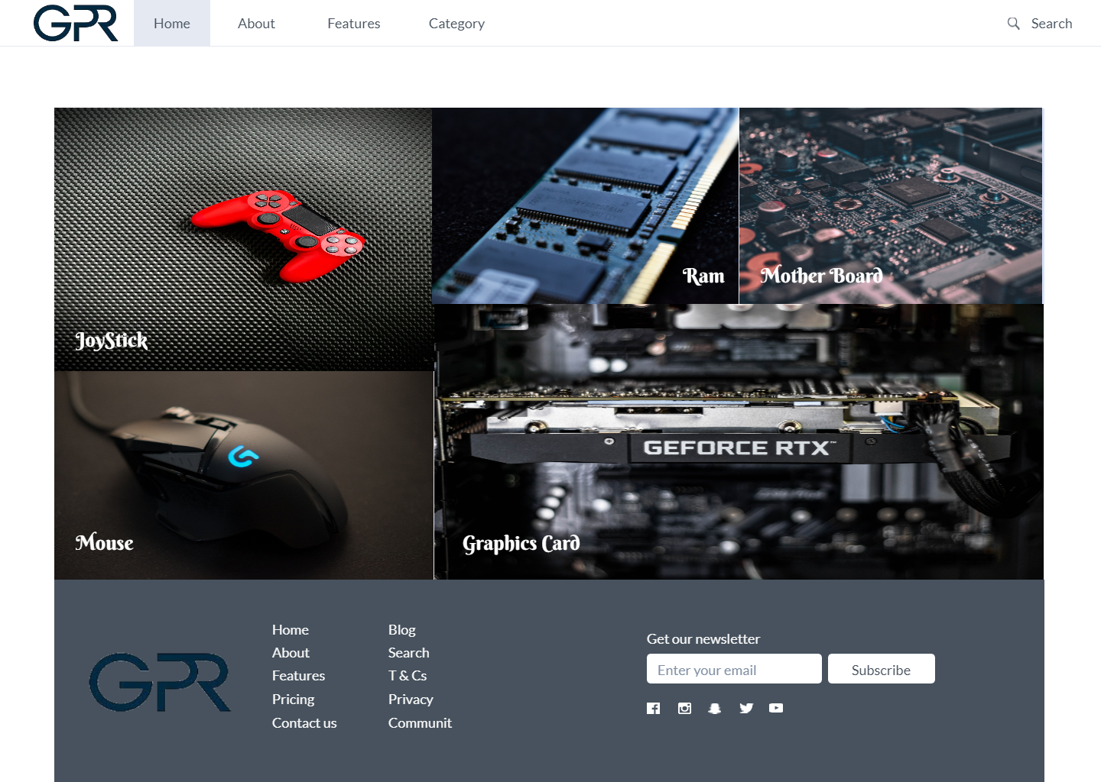

## 

## 

## Performance plan:

### Open-source web page tester (https://www.webpagetest.org/)

### Google Page evaluation (https://developers.google.com/speed/pagespeed/insights/)

# Development Plan

Development will stretch over 8 weeks and will be divided into two parts for convenience.

Development methodology will adopt agile methodology. Each cycle will complete in exactly 2 weeks (10 working days). At the end of each cycle, developing team will release a working software version. The platform planner team, UX designer team and the developer team will meet, run the software, test and provide their feedbacks vice versa. In the next cycle, each team updates their development plan within acceptable range of change.

## Phase 1

Duration: 3 weeks. In this phase the entire front end shall be complete. We will have a complete website with acceptable performance and user experience.

## Phase 2

Duration: 5 weeks. In this phase we will tackle the back end. We will create the database and establish connection. We will ensure user login authentication. Furthermore, host the final product on a suitable platform.

## Phase N

Phase N is future prospective of the project. The next feature can be a mobile version of the website for easier access. We could also add extra search features or product categories as well. This however , requires more planning given phase 1 and phase 2 has been executed successfully before deadline.

**Collaboration Plan**

Table 1: Collaboration plan

|  |  |
| --- | --- |
| **Tasks** | **Schedule** |
| Host dev-site and develop | ongoing basis |
| Functional testing | every Tuesday |
| Summary and discussion | every Tuesday |
| provide feedback on UI and functionality | as per need |
| use case testing | as per need |

# Project schedule

|  |  |  |  |  |  |  |  |  |
| --- | --- | --- | --- | --- | --- | --- | --- | --- |
| **Deliverables** | **Week1** | **Week2** | **Week3** | **Week4** | **Week5** | **Week6** | **Week7** | **Week8** |
| Front end |  |  |  |  |  |  |  |  |
| DB connection |  |  |  |  |  |  |  |  |
| User authentication |  |  |  |  |  |  |  |  |
| Search option system |  |  |  |  |  |  |  |  |
| Web Hosting |  |  |  |  |  |  |  |  |

Table 2: Development Schedule